ITEM DETAILS
Name of Item | Inter-War Flat
Other Name/s  Former Name/s | 69 Fletcher Street, Tamarama
Item type | Built
Item group | Flat Building
Item category | Flat
Area, Group, or Collection Name | Unknown
Street number | 69
Street name | Fletcher Street
Suburb/town | Tamarama |  |  |  |  | Postcode |  |  | 2026
Local Government Area/s | Waverley
Property description | SP 11361
Location - Lat/long | Latitude | -33.897866 |  | Longitude | 151.272964
Location - AMG (if no street address) | Zone |  |  | Easting |  |  |  | Northing
Owner | Private
Current use | Residential
Former Use | Residential
Statement of significance | 69 Fletcher Street, Tamarama (1938) is a good example of an Inter-War Art Deco flat building on a prominent corner location in Waverley. It demonstrates the development of the Mackenzie’s Ocean Estate 1920 subdivision, an important phase in the history of Waverley which represents the 1920s-1930s development boom, a prominent period of economic prosperity and speculative development in Waverley and it represents the development of Inter-War flat buildings, an important typology in Waverley associated with the changing demographics with a shift to living in flats.  69 Fletcher Street demonstrates the development of the Mackenzie’s Ocean Estate 1920 subdivision, an important phase in the history of Waverley which represents the changing land use from agricultural to residential.  The building is a notable example of the development of flat buildings in Tamarama and demonstrates the change in patterns in the late Inter-War period to incorporate garages which reflect the growth of private vehicle ownership.
Level of Significance | National |  | State |  |  |  | Local

DESCRIPTION
Designer

Builder/ maker | G. Rowles
Physical Description | 69 Fletcher Street, Tamarama is a three-storey freestanding flat building that dates from the Inter-War period (1938), the key period of significance of Mackenzie’s Ocean Estate subdivision, 1920. The building displays features of the Inter-War Art Deco style including symmetrical form, stepped parapet and façade, vertical fins and decorative face brick, which is now rendered, with parallel line motifs.  The building is setback 3 metres from the street on a regular and an elevated corner site approximately 12 metres wide, that reflects the original 1920 subdivision pattern in a suburban setting that has retained much of its historic context.  The site has a fence of face brick approximately 0.6 metres high, which compliments the setting of the place, and a driveway accessing basement garages. The site is informally landscaped and features mature trees and cypress hedging and provides an appropriate setting for the building. The plan layout features 3 flats per floor with side entry (Type 5 – Waverley Inter-War Flats Guidelines).  The building appears to be in excellent condition and is substantially intact.  Elements impacting upon the integrity of the site include rendered and painted face brick work (2007), roof additions, gable and dormers and rear balconies.
Physical condition  and  Archaeological potential | The building appears to be in excellent condition
Construction years | Start year | 1938 | Finish year | 1938 | Circa
Modifications and dates

HISTORY
Historical notes | Lot 16 in DP 10118, was subdivided by dairy farmer Frederick Alexander Mackenzie, and offered for Auction Sale in April 1920 as ‘Mackenzie’s Ocean Estate, Bondi’. Lot 16 was purchased by Violet Maude Roberts in June 1922, then to Ethel Clare Humphrey in 1923 and to Leslie Thomas Gordon, a clerk of Bondi, in January 1938. Plans for flats at the corner of Fletcher and Alexander Streets, Bondi, were submitted to Council in 1938. The client was noted as L. Gordon Esq. Only the engineer’s plans have been located. The builder was G. Rowles and the engineer was J.W. Woodfield.

THEMES
National  historical theme | 4 Building settlements, towns and cities  8 Developing Australia’s Cultural Life
State  historical theme | Towns, suburbs and villages  Land tenure  Accommodation  Domestic life  Creative endeavour
Local  historical theme | Flats and Bungalows  Speculation and Subdivision

Assessment
A: Historical Significance | 69 Fletcher Street, Tamarama has historical significance at a local level as it demonstrates the development of the Mackenzie’s Ocean Estate 1920 subdivision, an important phase in the history of Waverley which represents the 1920s-1930s development boom, a prominent period of economic prosperity and speculative development in Waverley.  69 Fletcher Street, Tamarama has historical significance at a local level as it demonstrates the changes in land use at Waverley, from agricultural (supplying produce including milk to the city) to residential.  69 Fletcher Street, Tamarama has historical significance at a local level as it represents the development of Inter-War flat buildings, an important typology in Waverley associated with the changing demographics with a shift to living in flats.  69 Fletcher Street, Tamarama is a notable example of the development of flat buildings in Tamarama and demonstrates the change in patterns in the late Inter-War period to incorporate garages which reflect the growth of private vehicle ownership.
B: Associative | To date no historic association has been identified.
C: Aesthetic significance | 69 Fletcher Street, Tamarama has aesthetic significance at a local level as a good example of an Inter-War Art Deco flat building on a prominent corner location. The building shows accomplished use of Inter-War Art Deco style including symmetrical form, stepped parapet and façade, vertical fins and decorative brickwork, which is now rendered, with parallel line motifs.
D: Social significance | To date no social, cultural, and spiritual significance has been identified.
e) Technical/  Research significance | To date no research/technical significance has been identified.
f) Rarity | To date research suggests that 69 Fletcher Street, Tamarama is not rare.
g) Representative-ness | 69 Fletcher Street, Tamarama has representative significance at a local level as a good example of an Inter-War Art Deco flat building in Waverley.
Integrity | The building is substantially intact.

HERITAGE LISTINGS
Heritage listing/s | Draft Waverley LEP 2012

INFORMATION SOURCES
Type | Author/Client | Title | Year | Repository
 | Waverley Council | Waverley Heritage Policy | 2007
 | Waverley Council | Waverley Heritage Study | 1993
 | Perumal Murphy Pty Ltd | Waverley Heritage Study | 1990
 |  | Certificate of Title Vol 3345 Fol 249 |  | NSW Land Registry Services.

RECOMMENDATIONS
Recommendations

SOURCE OF THIS INFORMATION
Name of study or report | Heritage Policy by Waverley Council reviewed by Architectural Projects 2023 |  | Year of study or report
Item number in study or report

Author of study or report
Inspected by
NSW Heritage Manual guidelines used? |  |  |  | Yes |  | No
This form completed by |  |  |  | Date

IMAGES

Image caption | 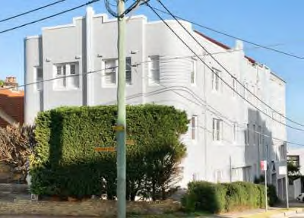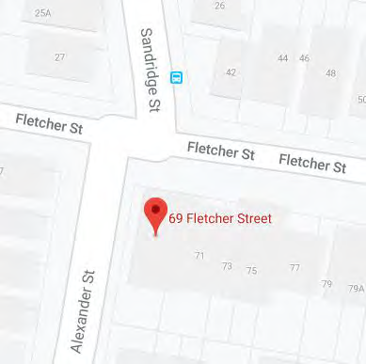
Image year |  | Image by | Google Maps | Image copyright holder

Image caption | 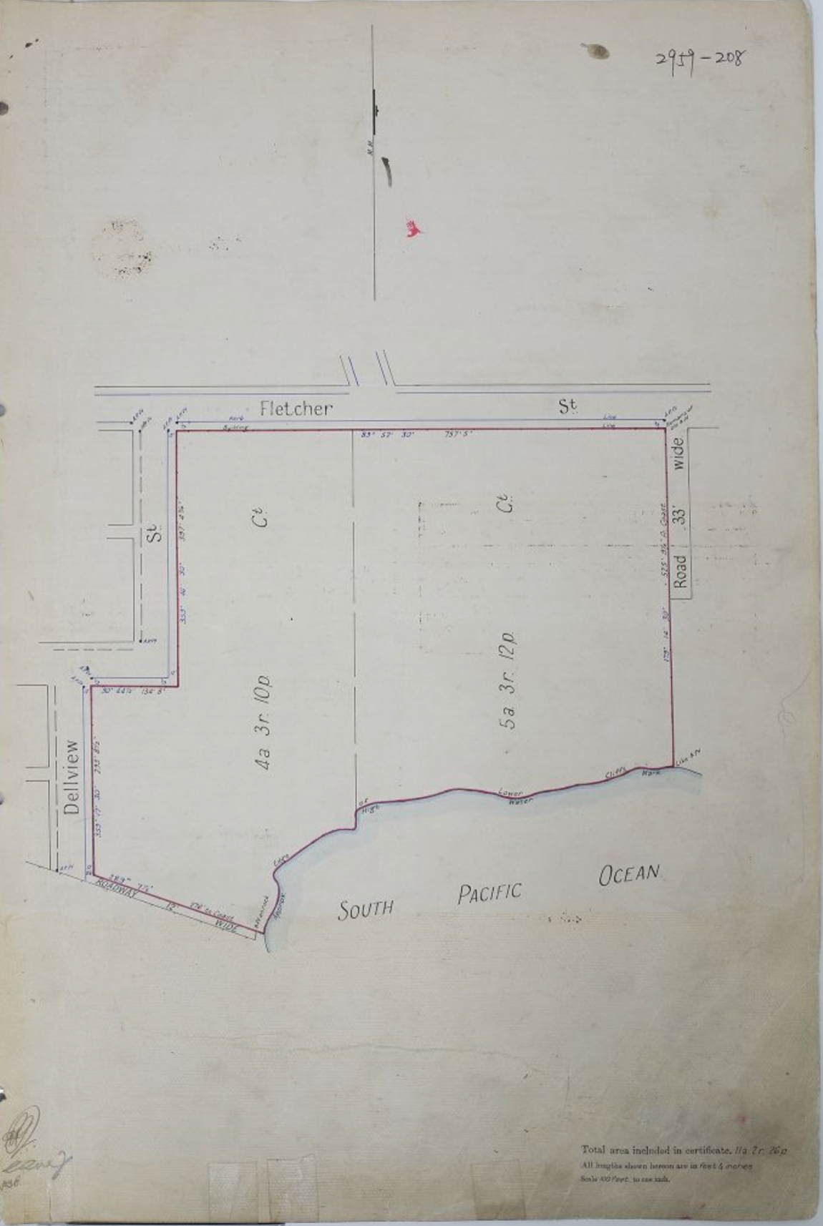
Image year | Undated | Image by | Historical Land Records Viewer | Image copyright holder

Image caption | 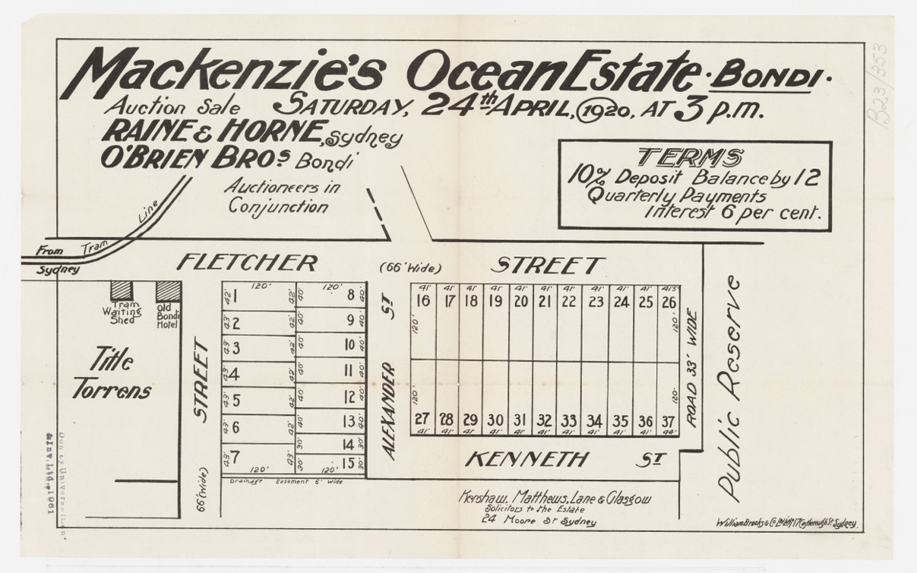
Image year | 1920 | Image by | State Library of New South Wales | Image copyright holder

Image caption | 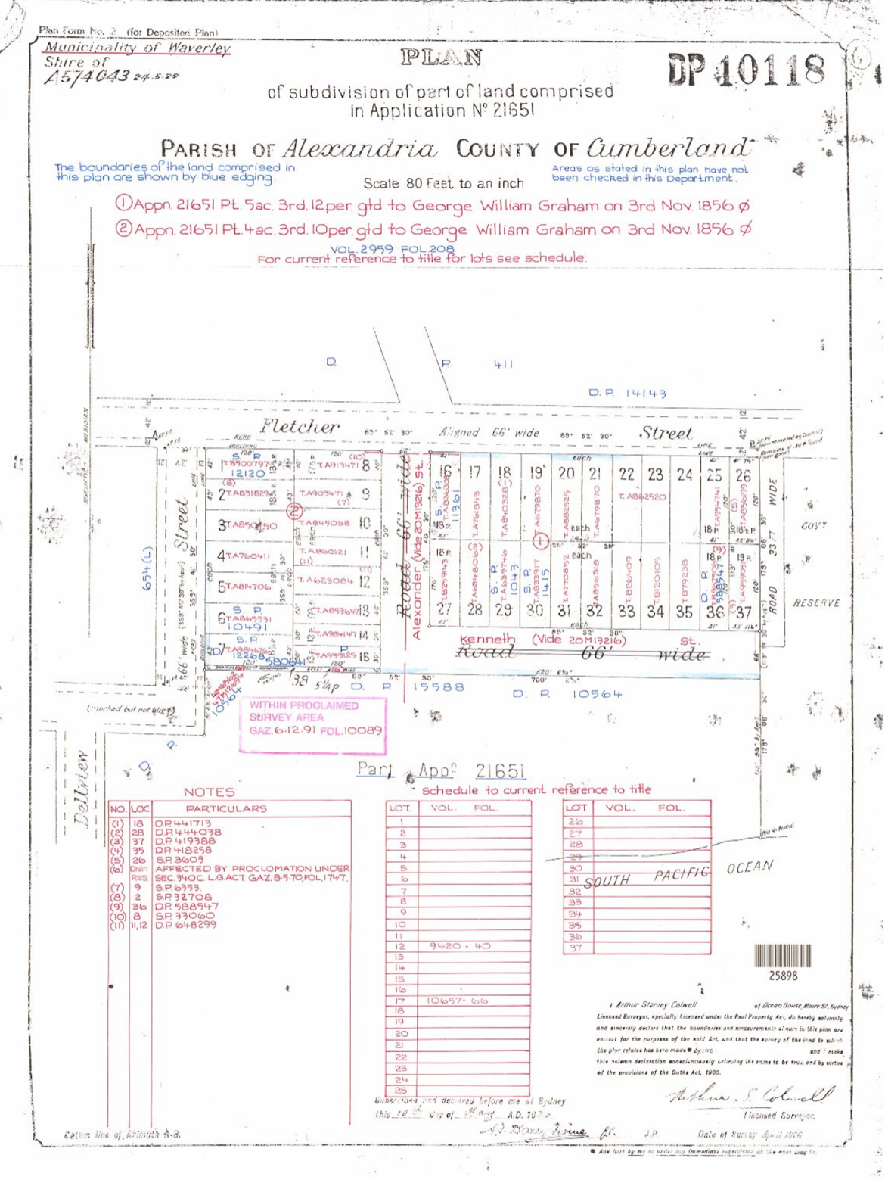
Image year | 1926 | Image by | LPI | Image copyright holder

Image caption | 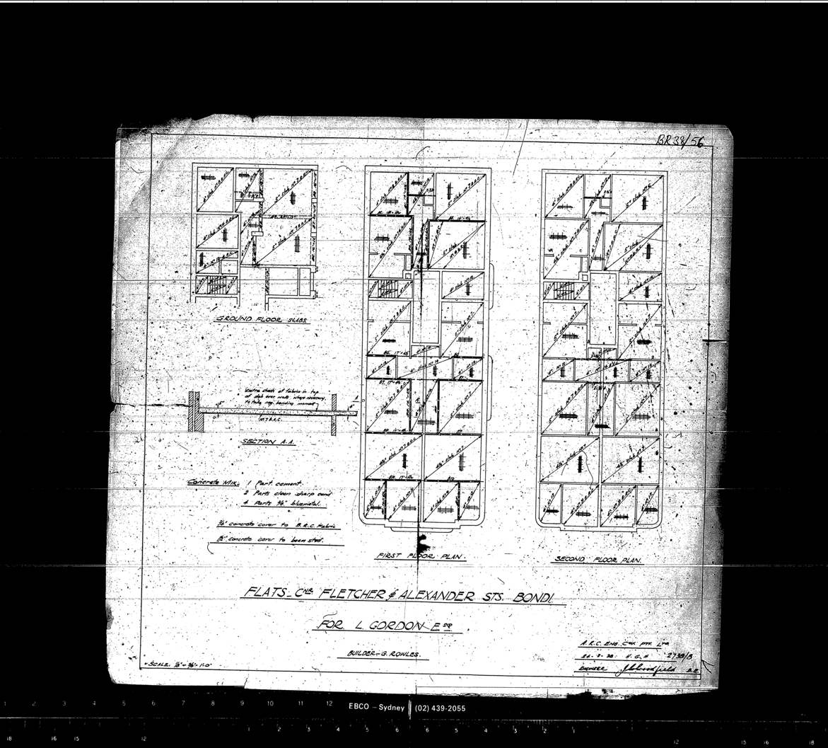
Image year | 1938 | Image by | Waverley Council | Image copyright holder

Image caption

Image year | 1938 | Image by | Waverley Council | Image copyright holder

